###### BRAND GUIDELINES





DESIGN BY MACANUDA STUDIO [macanuda.studio](https://macanuda.studio/) [hello@macanuda.studio](mailto:hello@macanuda.studio)



###### INTRODUCTION

### What are Brand Guidelines?

Brand Guidelines are a guide to teach how to properly use your branding and all the assets created, to make sure you stay consistent and communicate to your customers properly.

You can refer to it every time you need to create new assets, or you can send it to another designer in case you decide to work with someone new in the future.

### Contents

#### 01.

**The Brand**

#### 02.

##### Logo Suite

* **Primary Logo**
* **Clear Space**
* **Incorrect Use**
* **Logo Mark**

#### 03.

##### Colour palette

* **Colour Pairings**

#### 04.

##### Typography

* **Font Suite**
* **Fonts In Use**

#### 05.

##### Brand assets

* **Brand Elements**
* **Brand Icons**

#### 06.

**Brand in action**

## The brand



###### ABOUT THE BRAND

### Who is Arieke?

Arieke is a movement builder with a passion for moving people towards a green and fair world. She believes that when seen by the right people, stories can change the world. That’s why she creates and brings to life media productions, events and campaigns about the most important challenges of our time.

She is passionate about topics like climate, human rights, politics, feminism, diversity, inclusivity, LGBTQIA, culture, education and much more.

## Logo suite

###### LOGO SUITE

### Primary Logo

You primary logo is the main voice and signature of your brand. This should be used most frequently when space allows for it.

Think of your primary logo as the trunk of a tree and the other logo marks and variations as the branches.



This logo should be used on websites, headers, footers, stationery, signage and any other larger elements.

###### CLEAR SPACE

### Clear Space

To ensure clear visibility and presence, it’s essential to respect the clear space in all applications.



|  |  |  |
| --- | --- | --- |
|  |  |  |
|  |  |  |
|  |  |  |

This way, other graphic elements, text or components won’t interfere or compromise legibility.

The dimensions of this area are determined by taking the letter “a” from the logo and placing it as shown.

###### INCORRECT USE

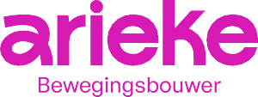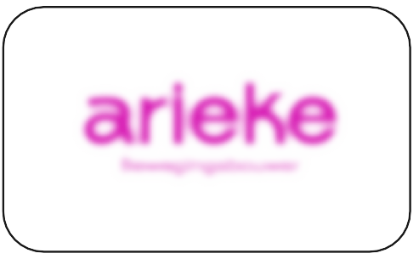

Do not reproduce the logo in unauthorized colors.



Do not add elements to the logo.

Do not place the logo on clashing backgrounds.

Do not change the position of the graphic elements.



Do not add any outlines, strokes, or dropshadows to the logotype.



Do not stretch or squish the logo.

###### LOGO SUITE

### Logo Mark

Logo marks are a simpliﬁed version of your main logo. Having something simpler works well when you have a more conﬁned space to ﬁll.

This can be used in smaller spaces like social proﬁle photos, stamps, favicon etc. If it’s a small space, your other logo variations simply wont ﬁt, so it’s best to use your logo mark.



## Colour palette

**RGB: 38 21 1 124 HEX: #26D37C CMYK: 67 0 67 0**

**Primary**

**RGB: 255 255 255 HEX: #FFFFFF CMYK: 0 0 0 0**

**Complementary**

**RGB: 0 0 0**

**HEX: #000000**

**CMYK: 91 79 62 97**

**Complementary**

**RGB: 216 26 180 HEX: #D81AB4 CMYK: 34 85 0 0**

**Accent**

###### BRAND COLOURS

### Colour palette

RGB: Stands for Red, Green & Blue

colours. This is used on-screen and for web design.

HEX Code: This colour code is used on-screen and for web design.

CMYK: Stands for ‘Cyan, Magenta, Yellow & Key (black)’ colours. They are the colours used in printed materials.

•

Bewegingsbouwer

**e**

•

Bewegingsbouwer

**e**

# e

•

Bewegingsbouwer

**e**

Bewegingsbouwer

## Typography

###### FONT SUITE

### Typography

The main brand font is General Sans, in different weights. It’s a modern, sans serif font that’s round, simple and easy to read.

For headers, you can use it in uppercase and combine it with the brush font to highlight certain words.

<https://www.fontshare.com/fonts/general->sans

<https://creativemarket.com/MadeType/34> 24481-MADE-Soulmaze

**Header Font - General Sans (Bold)**

**abcdefghjklmnopqrstuvwxyz ABCDEFGHJKLMNOPQRSTUVWXYZ 0123456789.,;:’”(!?)ò+-*/=**

**AA**

**Accent Font - MADE Soulmaze Brush**

*AA*

*ABCDEFGHJKLMNOPQRSTUVWXYZ 0123456789.,;:’”(!?)ò+-*/=*

**Subheader Font - General Sans (Semibold)**

**Aa**

**abcdefghjklmnopqrstuvwxyz ABCDEFGHJKLMNOPQRSTUVWX-YZ**

**0123456789.,;:’”(!?)ò+-*/=**

**Body Font - General Sans (Regular)**

**Aa**

**abcdefghjklmnopqrstuvwxyz ABCDEFGHJKLMNOPQRSTUVWXYZ 0123456789.,;:’”(!?)ò+-*/=**

###### FONTS IN USE

**THIS IS THE** *HEADER*

**This is the subheader**

**Lorem ipsum dolor sit amet, consectetuer adipiscing elit, sed diam nonummy nibh euismod tincidunt ut laoreet dolore magna aliquam erat volutpat. Ut wisi enim ad minim veniam, quis nostrud exerci tation ullamcorper suscipit lobortis nisl ut aliquip ex ea commodo**

## Brand assets



###### BRAND ASSETS

### Brand elements

Simple abstract shapes combined with more speciﬁc ones that relate to the topics you work on to make the mosaic unique to your brand.

###### BRAND ASSETS

### Brand icons

A set of custom made icons that can be used within the social media templates to keep the content organized according to the topic discussed.

**Energy, food, water**



**Climate**



**Innovation**

**Community / Identity / Diversity and Inclusion Emancipation / Gender / Feminism / Family**



**Healthcare**

**Human rights / politics**



**Media / new work**

**Mobility**



**Location LGBTQIA+**



**Art, culture**

**Education**



## Brand in action

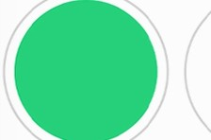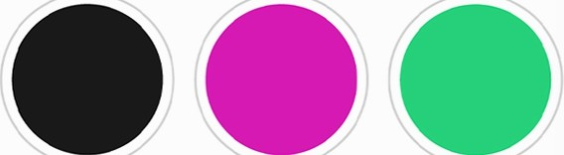

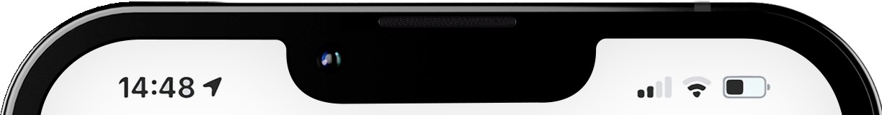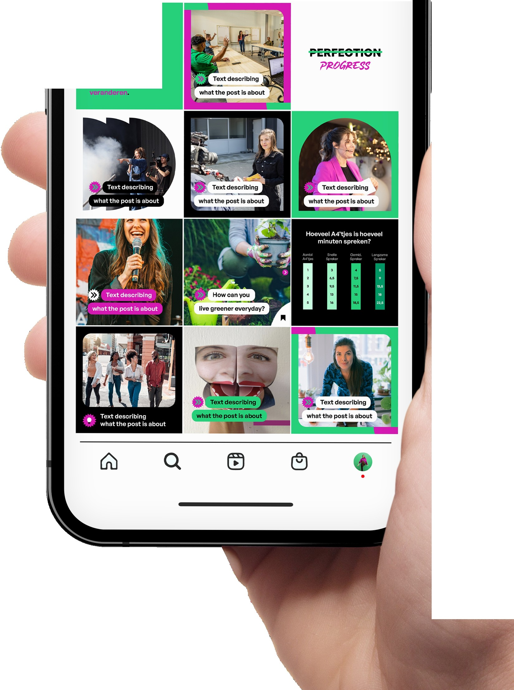

<

0

Posts

1

0

Follower Following

**Verhalen, gezlendoor dejulste mensen, hebben de kreoht**

**om de wereld te**

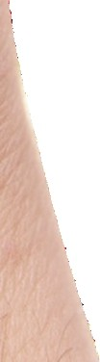

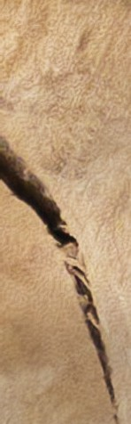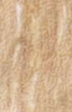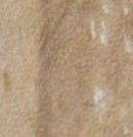

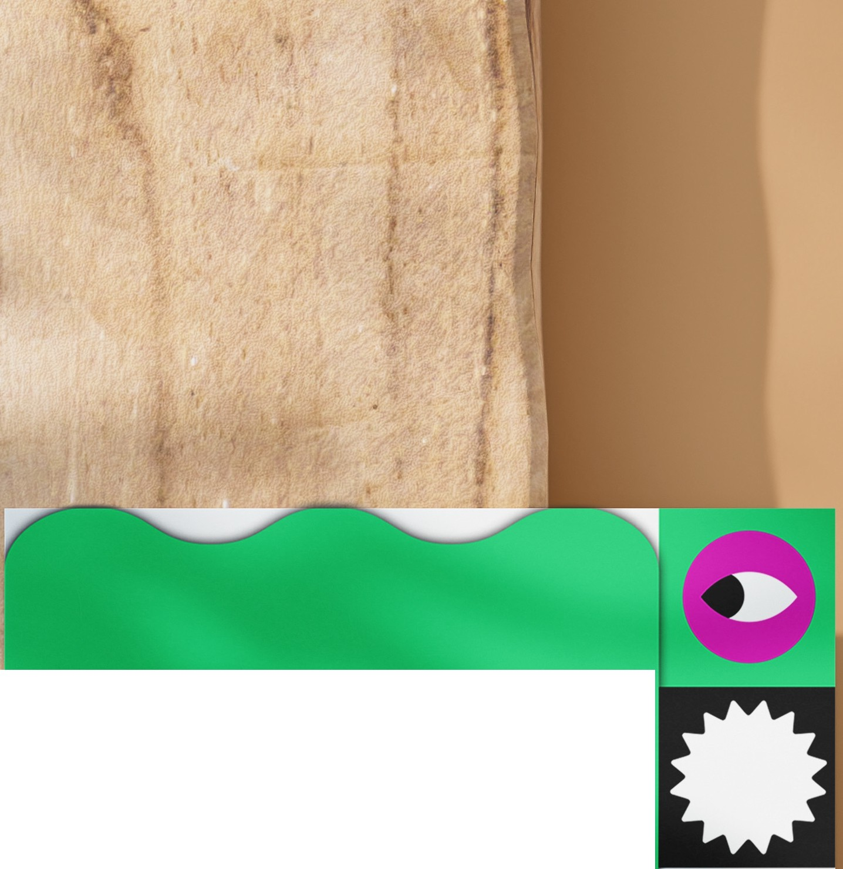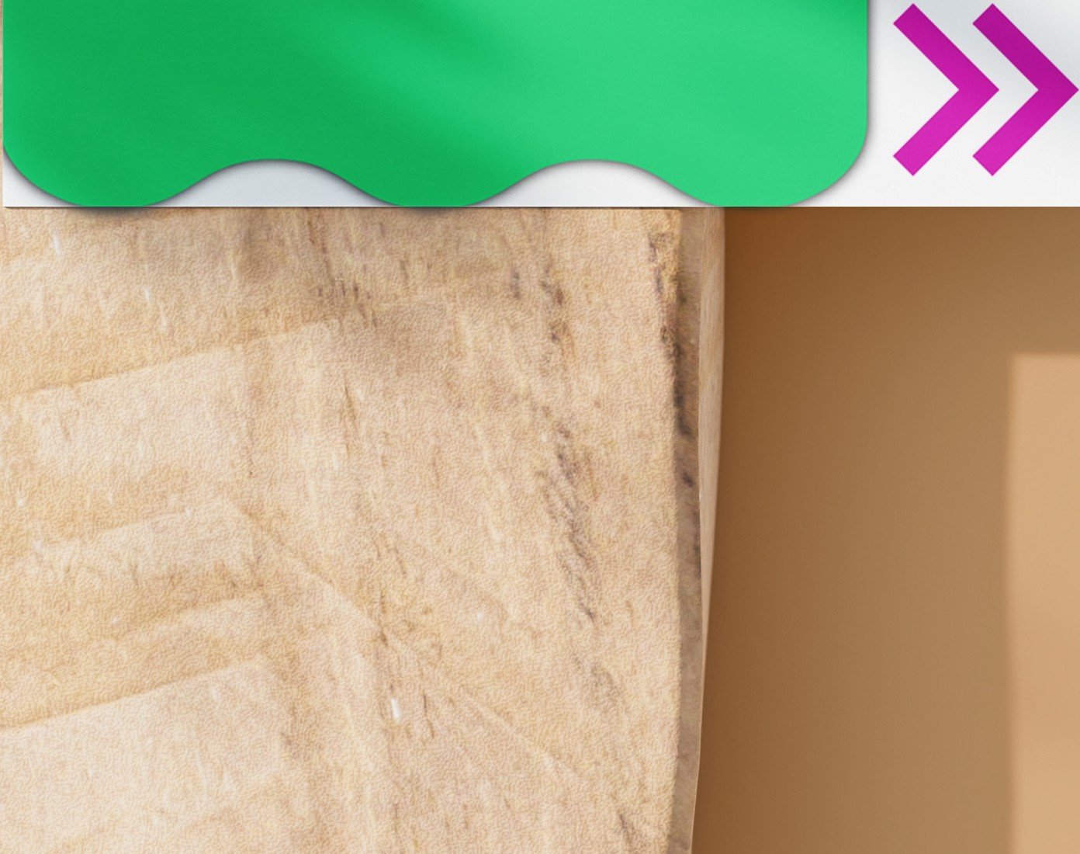

**arieke**

Bewegingsbouwer

###### BRAND GUIDELINES





DESIGN BY MACANUDA STUDIO macanuda.studio [hello@macanuda.studio](mailto:hello@macanuda.studio)

